Inventory Allocator Program

Steps to execute the .jar file:

1. Download the .jar file
2. Open Command prompt and change the directory path to the location where the file has been downloaded. 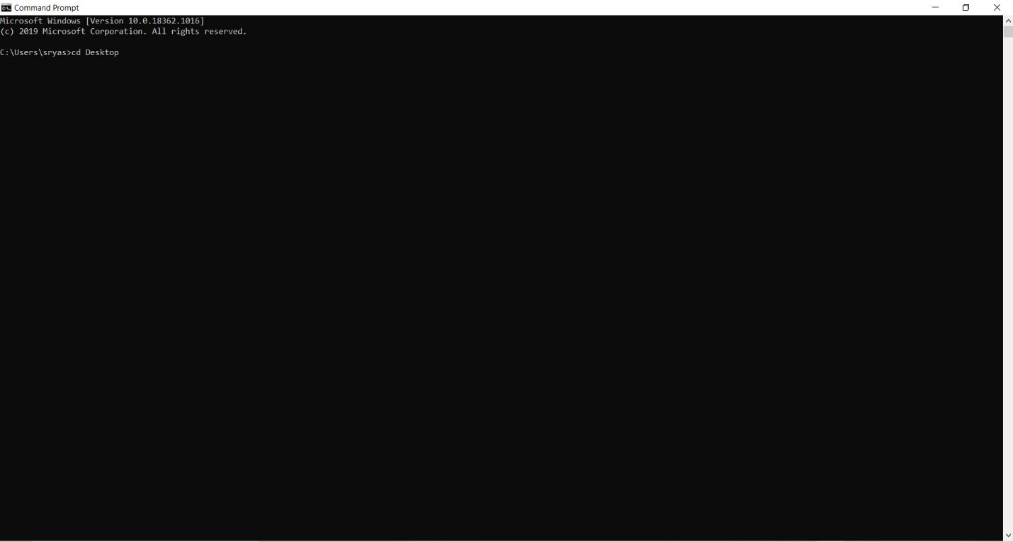
3. Enter the command “java -jar InventoryAllocationProgram.jar” to execute the program.

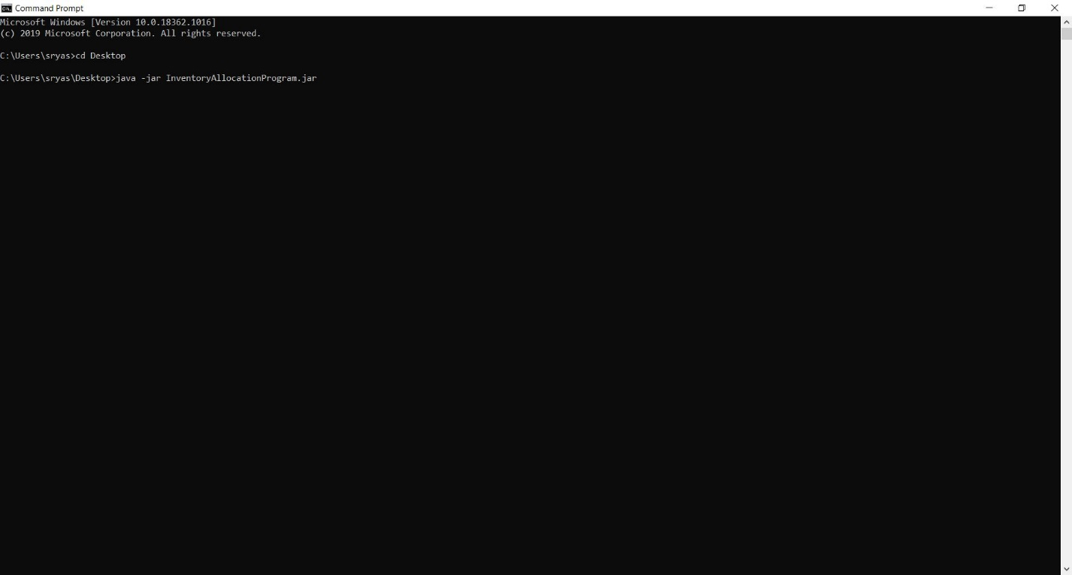

1. When the program executes enter the required option to procced with the inventory allocation. Enter “M” to manually enter a string and test the output.

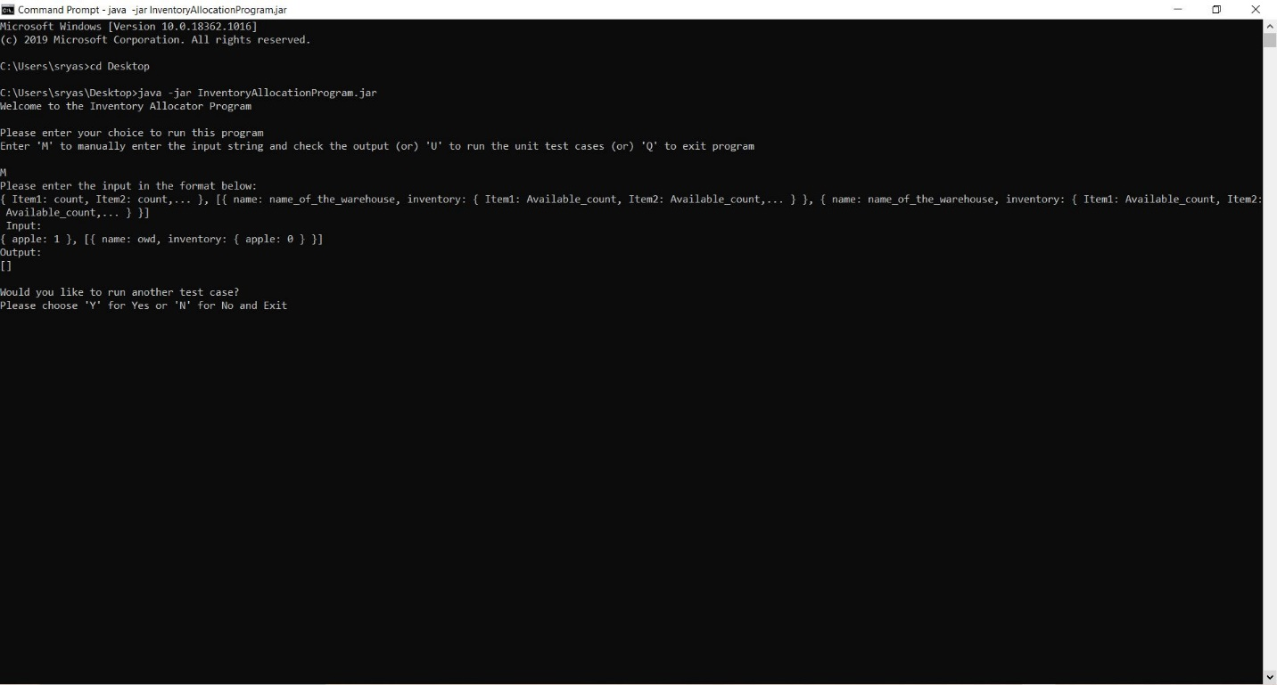

1. Enter “U” to run the Junit Test Cases. A total of 60 test cases are written for this program to show that the output string matches the conditions mentioned for this Inventory Allocation Program.

